Name: Jesse Abigail Victor

Matric No.: HCSF/23/0043

Department: Computer Science

Level: HND 1

Course Code: COM 322

ASSIGNMENT

1. THE UNIX SHELL

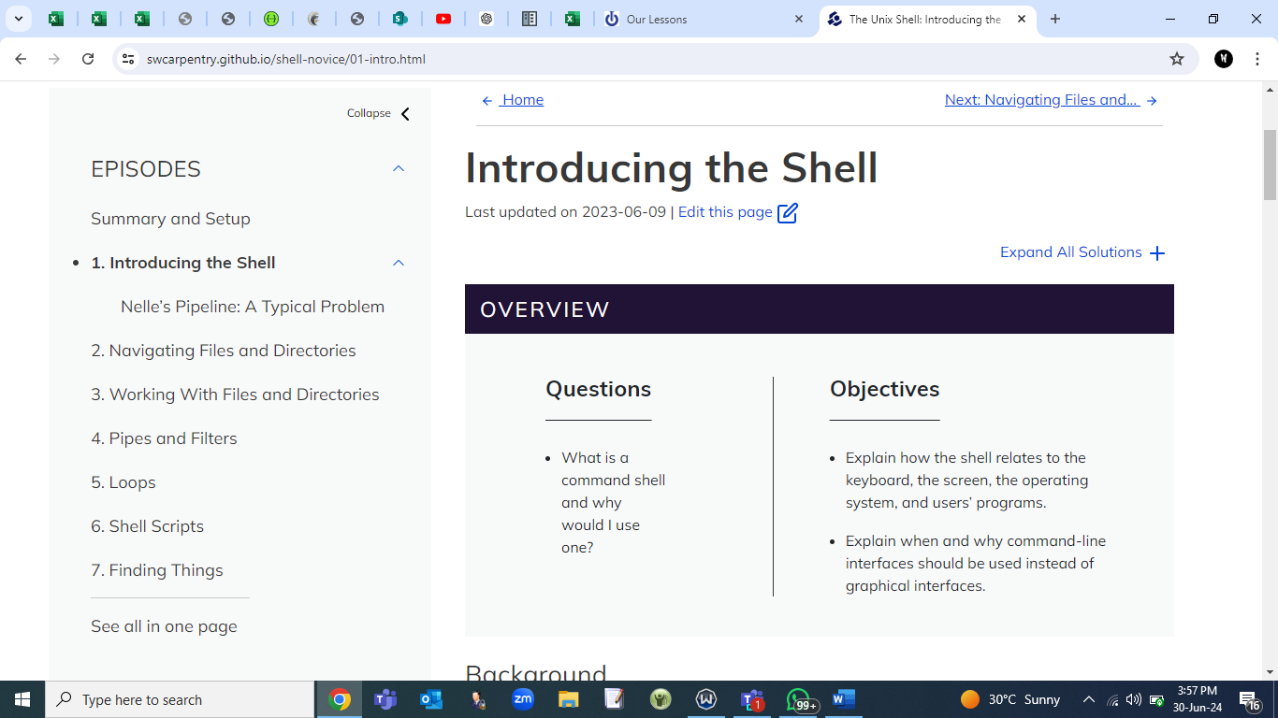

1. VERSION CONTROL WITH GIT

